COLLATZ CONJECTURE AND ITS SIMPLE PROVE
By: Budi Hartono

- Basic statement of collatz conjecture

It is arithmetic proccess. Choose any positive integer, if odd multiply by three then add one (3n+1). If even, divide it by two (n/2). Repeat. No matter where you start, it will eventualy reach 1.

- Basic concept in this rough manuscript

Cycle : Repeating sequences. It start and ended with same number. For example: 1→4→2→1
Trivial cycle : Cycle that is already known: 1→4→2→1.
Nontrivial cycle : Other cycle that is not 1→4→2→1. Collatz conjecture says that there is no nontrivial cycle.
Trajectory : Sequence of numbers obtained by repeatedly applying the Collatz function.
Convergent trajectory : A trajectory that eventually reaches 1
Divergent trajectory: A trajectory that grows without bound and never enters a cycle. The conjecture says there is no divergence.
Seed : The starting number of the sequences. In this manuscript, from this point onward, the seed will always be odd numbers.

- How it can be proven/disproven

To prove/disprove the conjecture is simply to prove/disprove the existence of nontrivial cycle and or divergent trajectory.

- Cycle in collatz conjecture

- The nature of cycle

Let’s say, it’s the trivial cycle. The blue arrows represent n/2. The red arrows represent 3n+1
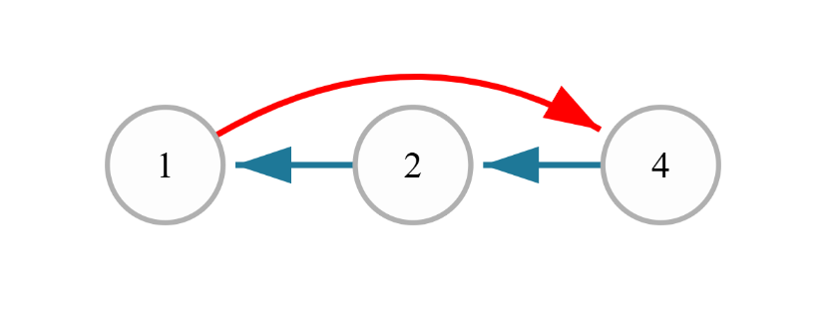
You can flip the blue arrows,
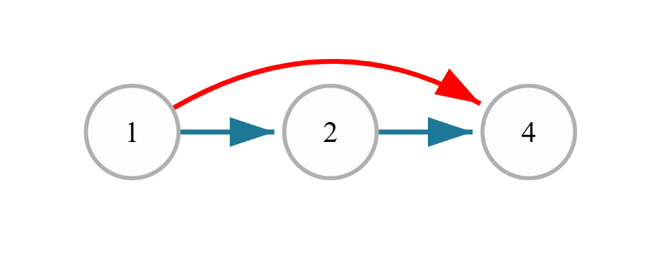
This way, you can make the blue represent $n.2^{k}$ where k is the number of how many time you do this function to the seed. We wil called it as BLUE FUNCTION from now onward. RED FUNCTION is its counter part, 3n+1 or its shortcuts. For example, $\frac{3^{i}n + 3^{i}– 2^{k}}{2^{i-1}}$ with i is how many time you this function to the seed. I differentiate k and i because they can have different numbers, which will be shown in the future.

To find a cycle, tivial or not, is simply to find BLUE FUNCTION = RED FUNCTION

$$n.2^{k}=\frac{3^{i}n + 3^{i}- 2^{i}}{2^{i}}$$

- Experiments
Let’s prove it. Let’s say
$$n.2^{}=\frac{\left\{9n+5\right\}}{4}$$
$$8n=9n+5$$
$$n=-5$$

Now let’s see if it is true
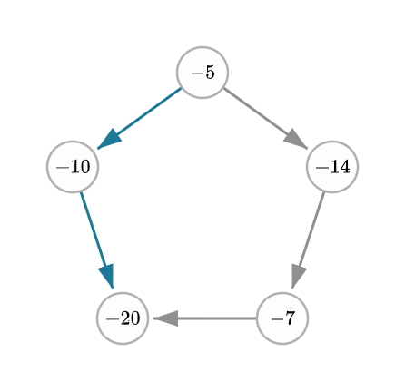
Let’s try another one

$$n.2^{4}=\frac{\left\{27n+19\right\}}{8}$$
$$128n=27n+19$$
$$n=\frac{19}{101}$$

Let’s prove if it can result in cycle
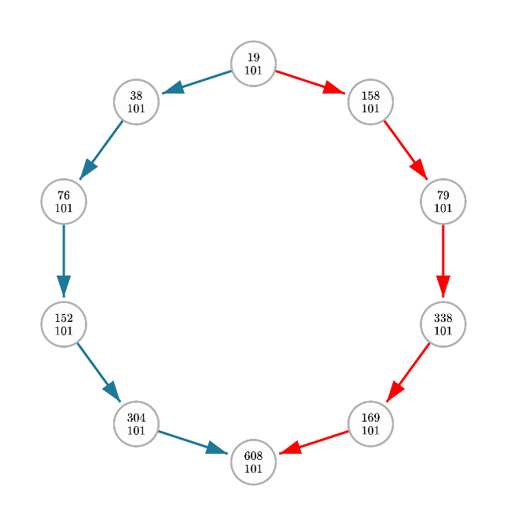

- Combinations between two functions

If you the calculation over and over again, you will get the table below:
$$Row$$ | $$\frac{3n + 1}{2}$$ | $$\frac{9n + 5}{4}$$ | $$\frac{27n + 19}{8}$$ | $$\frac{81n + 65}{16}$$ | $$\frac{243n + 211}{32}$$ | $$\frac{729n + 665}{64}$$ | $$\frac{2187n + 2059}{128}$$ | $$\frac{6561n + 6305}{256}$$
$$n$$ | $$-1$$ | $$-1$$ | $$-1$$ | $$-1$$ | $$-1$$ | $$-1$$ | $$-1$$ | $$-1$$
$$2n$$ | $$1$$ | $$-5$$ | $$-\frac{19}{11}$$ | $$-\frac{65}{49}$$ | $$-\frac{211}{179}$$ | $$-\frac{665}{601}$$ | $$-\frac{2059}{1931}$$ | $$-\frac{6305}{6049}$$
$$4n$$ | $$\frac{1}{5}$$ | $$\frac{5}{7}$$ | $$\frac{19}{5}$$ | $$-\frac{65}{17}$$ | $$-\frac{211}{115}$$ | $$-\frac{665}{473}$$ | $$-\frac{2059}{1675}$$ | $$-\frac{6305}{5537}$$
$$8n$$ | $$\frac{1}{13}$$ | $$\frac{5}{23}$$ | $$\frac{19}{37}$$ | $$\frac{65}{47}$$ | $$\frac{211}{13}$$ | $$-\frac{95}{31}$$ | $$-\frac{2059}{1163}$$ | $$-\frac{6305}{4513}$$
$$16n$$ | $$\frac{1}{29}$$ | $$\frac{1}{11}$$ | $$\frac{19}{101}$$ | $$\frac{13}{35}$$ | $$\frac{211}{269}$$ | $$\frac{133}{59}$$ | $$-\frac{2059}{139}$$ | $$-\frac{1261}{493}$$
$$32n$$ | $$\frac{1}{61}$$ | $$\frac{5}{119}$$ | $$\frac{19}{229}$$ | $$\frac{65}{431}$$ | $$\frac{211}{781}$$ | $$\frac{665}{1319}$$ | $$\frac{2059}{1909}$$ | $$\frac{6305}{1631}$$
$$64n$$ | $$\frac{1}{125}$$ | $$\frac{5}{247}$$ | $$\frac{19}{485}$$ | $$\frac{65}{943}$$ | $$\frac{211}{1805}$$ | $$\frac{95}{481}$$ | $$\frac{2059}{6005}$$ | $$\frac{6305}{9823}$$
$$128n$$ | $$\frac{1}{253}$$ | $$\frac{5}{503}$$ | $$\frac{19}{997}$$ | $$\frac{65}{1967}$$ | $$\frac{211}{3853}$$ | $$\frac{665}{7463}$$ | $$\frac{2059}{14197}$$ | $$\frac{6305}{26207}$$

As you can see, generally, the bigger the cycle is, the least likely it will satisfy the criteria stated in the conjecture. The n value is getting smaller compared to its shorter counterpart. It getting even smaller if we calculate the division of even numbers in RED FUNCTION.
$$n.2^{k}=\frac{3^{i}n + 3^{i}- 2^{i}}{2^{i}}$$
$$n.2^{k}.2^{i}=\left(3^{i}n + 3^{i}- 2^{i}\right)$$
$$n.2^{k}.2^{i}-3^{i}n=\left( 3^{i}- 2^{i}\right)$$
$$n.{(2}^{k}.2^{i}-3^{i})=\left( 3^{i}- 2^{i}\right)$$
$$n=\frac{\left( 3^{i}- 2^{i}\right)}{{(2}^{k}.2^{i}-3^{i})}$$

So, it can be safely deducted that there is no nontrivial cycle that fit the criteria of collatz conjecture.

- Global convergence to 1

In this moment, we intuitively know that all numbers should converge to 1. After all, we already know that there is no other cycle that satisfy the conjecture beyond the trivial cycle. Beside, when we do the experiment of all positive integer, we get consistent repeated pattern that it sounds absurd if it break randomly in some number. But intuitively knowing something doesn’t really equal to prove it. But, that’s okay. We will try to prove it here anyway.

There are many way to proof the convergence nature in this conjecture. Here, we will start it with a claim or proposition that any numbers connected to numbers that proven to be convergence, will also convergence by default.

First thing first, we will list everything we know and agree as true, then we will build our prove little by little

- We know that if the seed is convergent, then all of its BLUE FUNCTION is also convergent.
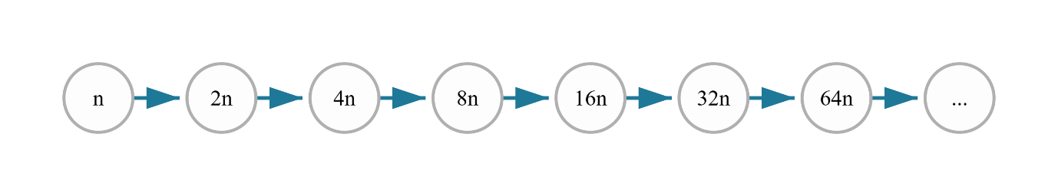
- We also know that if the seed is convergent, then all of its RED FUNCTION is also convergent
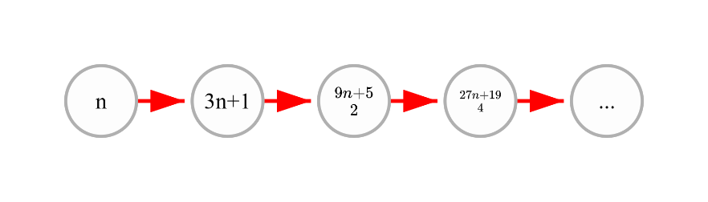

- All numbers/seed that its RED FUNCTION is connected to BLUE FUNCTION is also convergent.
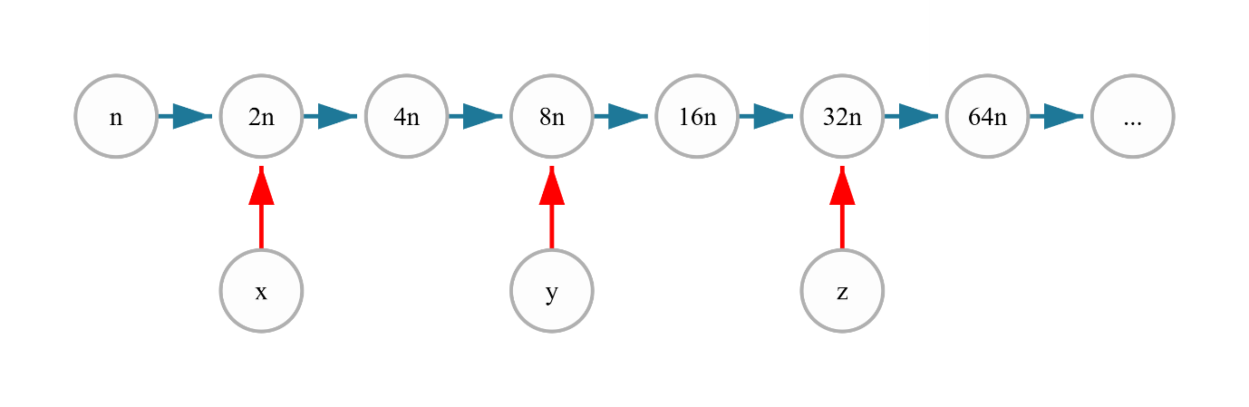

- The gaps of resut from RED FUNCTION is 6 from each other
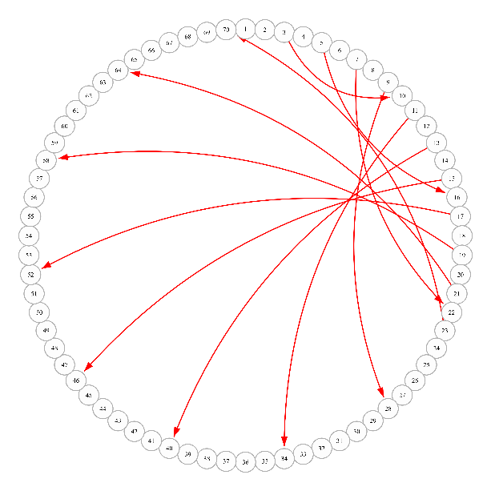

- Not all numbers in the gaps mentioned in point 4 have RED FUNCTION conected to BLUE FUNCTION as mentioned in point 3.

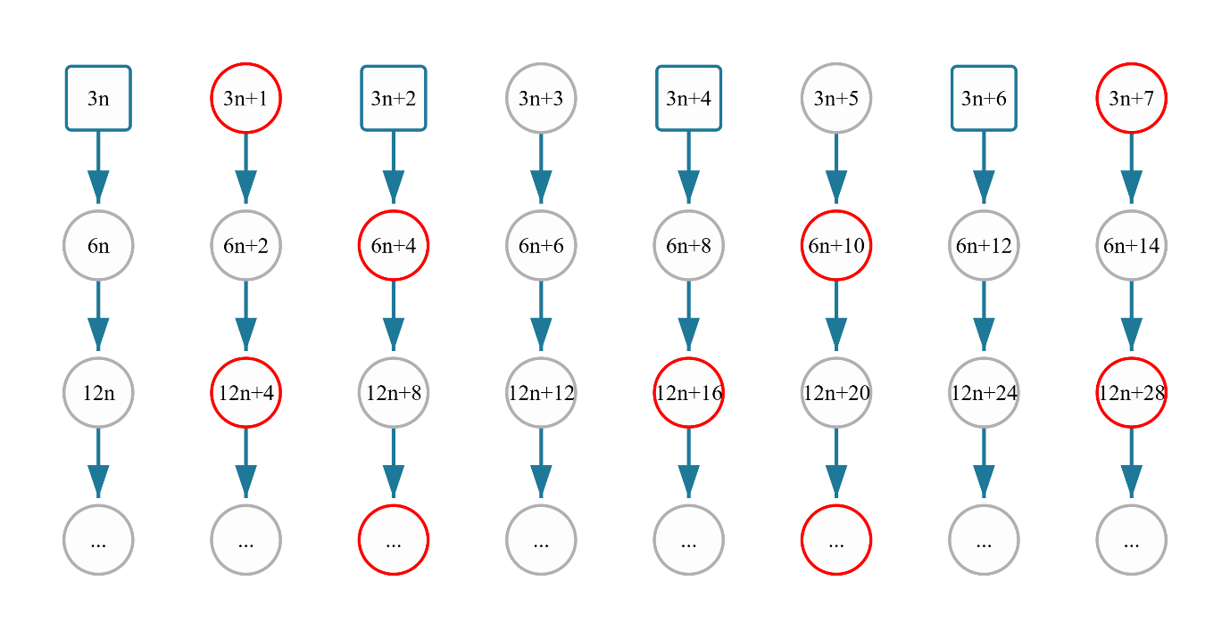
- As seen in point 5, RED CIRCLES represent either the gaps or the numbers that are conected to any RED FUNCTION , the CIRCLES represent even numbers, and the SQUARES represent the odd numbers. Let’s say all numbers below 3n is convergent, and x is a mysterious number above that. If x is CIRCLE, then it’s even number, which mean it’s related to previous number that is already known as convergent to 1, therefore it’s also convergent.
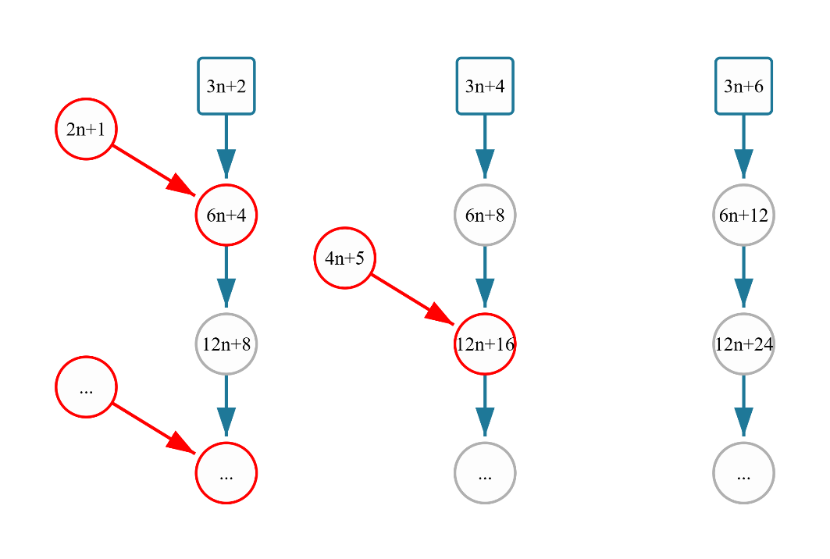

- As you can see, $3n+2$ is conected to $2n+1$ which is less than $3n$ as the limit ($if n is odd, and n>1$). That’s mean, if $x=3n+2$, then it is definitely convergent. Now, we only need to prove if 3n+4 and 3n+6 are also convergent. Now, let me remind you that this pattern is repeated over and over again across the all numbers
- If you are paying attention to those pattern, you will realize that there are only some types of numbers regarding on how it’s related to its seeds (which are only 2 types, even and odd). Those types are 3n, 3n+1, and 3n+2.
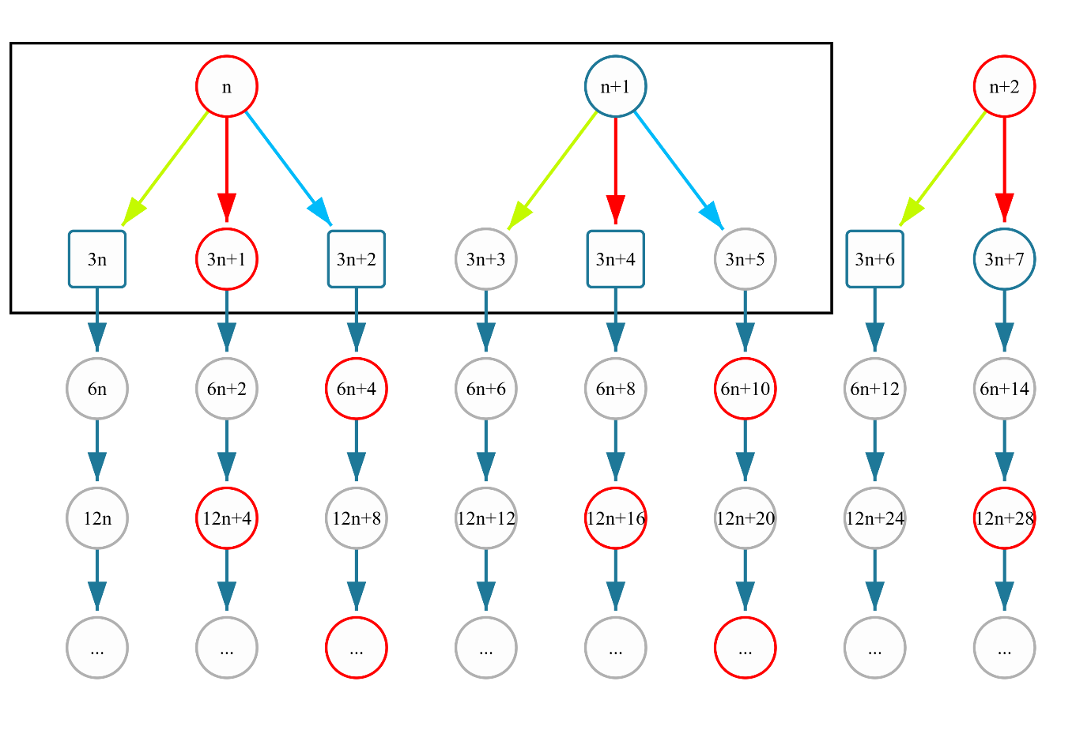

- The image above is for clasification only, since $n+1$ ia even number, so it can’t legally create $3n+4$. But it is useful classification.

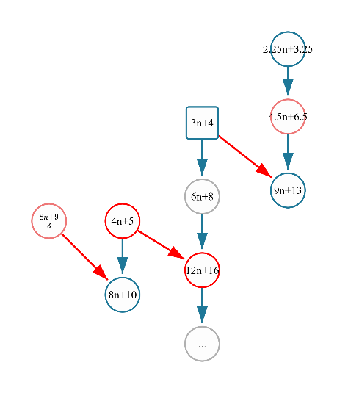

- As you can see, there are two way $3n+4$ can is connected to numbers below boundary through $4.5n+6.5$. it is unique because $4.5n+6.5$ can be either even or odd number, depends on the value of n. For example, it will be odd number if n=1, 5, ,..., and it will be even if the value of n is 3, 7, ...

